34.45: a) 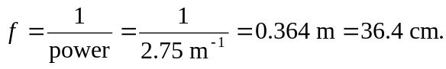 The near-point is normally at
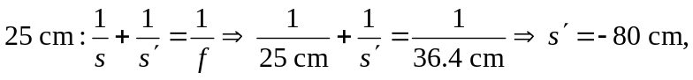 in front of the eye.
b) 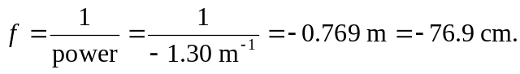 The far point is ideally at
infinity, so: 